<https://codeshare.io/5Dmwmm>

1. Drawing of state machine

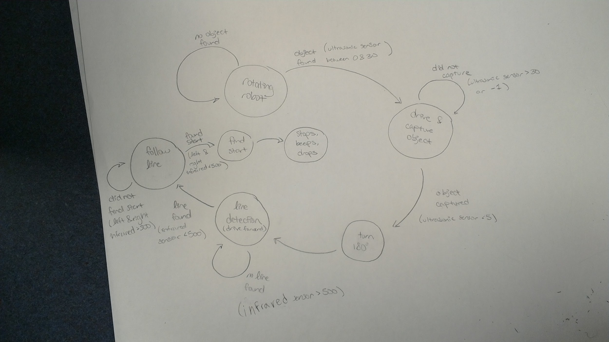

1. Names

Lara Chunko

Ayush Khanal

Brian Nguyen

Matthew Strong

Elijah Berumen

1. Were you able to get your program to complete the task? If not, which parts failed and why?

Yes

1. Former experience with C programming language

Lara Chunko: beginner

Ayush Khanal: advanced

Brian Nguyen: proficient

Matthew Strong: advanced

Elijah Berumen: Intermediate(Not for robotics though)

1. Level of prior experience with Arduino

Lara Chunko: none

Ayush Khanal: advanced

Brian Nguyen: beginner

Matthew Strong: advanced

Elijah Berumen: Beginner

1. Time spent on programming Part 2

Five hours

1. Brief description of any problems

* Flashing the Arduino was a pain
* The map was hard to drive on